Long Covid Survey Partner social media TOOLKit

March 2024

Link to CURE ID: CURE-ID (ncats.io) or download the “CURE ID” mobile app from the App or Play Store
CURE ID Long COVID FAQ Document: https://cure.ncats.io/assets/faq-long-covid.pdf
Accessibility note: If users need assistance entering cases, please reach out to curesupport@nih.gov, we have staff who are available to assist by email, phone, and/or Zoom.

Twitter Graphics
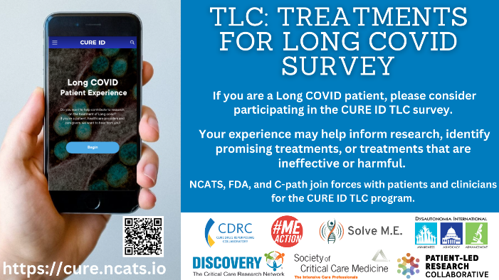

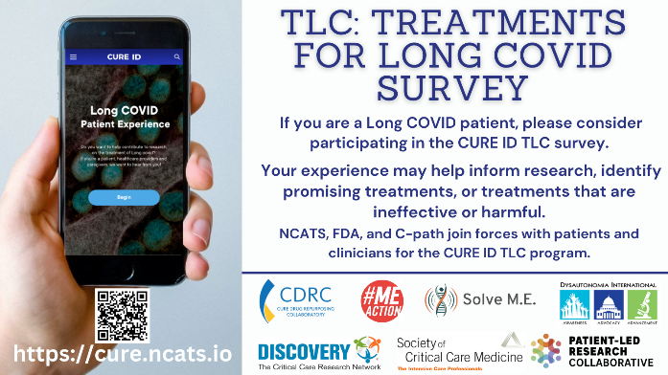
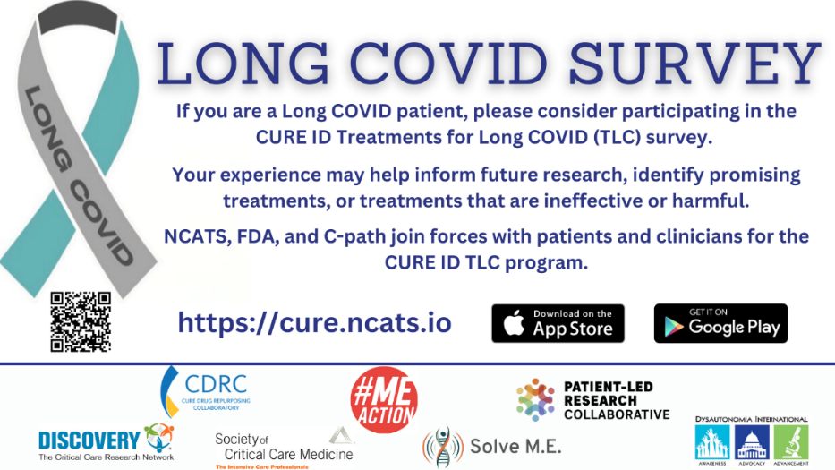

Sample Tweets:

- Are you or someone you know experiencing symptoms of #LongCOVID? Help us understand the long-term impact of COVID-19 by participating in our treatment survey. Visit CURE-ID (ncats.io) or download the “CURE ID” app!

- Calling all #LongCOVID long-haulers! Share your treatment experience by taking part in our research survey. Together, we can raise awareness and drive progress in research and care. Visit CURE-ID (ncats.io) or download the “CURE ID” app!

- Calling all people with #LongCOVID! If you're living with the aftermath of COVID-19, your experience matters! Complete our treatment survey (it takes ~20-45 mins) - Visit CURE-ID (ncats.io) or download the “CURE ID” app!

- Attention #LongCOVID community! 📢 Your insights are invaluable! Participate in our survey to help understand potential treatments. It takes ~20-45 minutes to complete. Visit CURE-ID (ncats.io) or download the “CURE ID” app!

- We need your input! Participate in our research survey to help increase our understanding of #LongCOVID treatments and their impacts. It takes ~20-45 minutes to complete. Visit CURE-ID (ncats.io) or download the “CURE ID” app!

- Participate in the CURE ID TLC survey to increase our understanding of #LongCOVID treatments. Visit CURE-ID (ncats.io) or download the “CURE ID” app!

- Participate in the CURE ID TLC #LongCOVID survey - an initiative developed with @Dysautonomia, @patientled, @MEActNet @PlzSolveCFS, @LongCOVIDAllian, in collaboration with @NIH @FDA and @CPathInstitute, who host CURE ID. Visit CURE-ID (ncats.io) or download the “CURE ID” app!

Tag:
@id_cure, @MEActNet, @CPathInstitute, @SCCM, @ncats_nih_gov, @LongCOVIDAllian, @PlzSolveCFS, @patientled, @Dysautonomia

Link to CURE ID: CURE-ID (ncats.io)
CURE ID Long COVID FAQ Document: https://cure.ncats.io/assets/faq-long-covid.pdf
Accessibility note: If users need assistance entering cases, please reach out to curesupport@nih.gov, we have staff who are available to assist by email, phone, and/or Zoom.

Facebook/Instagram Graphics
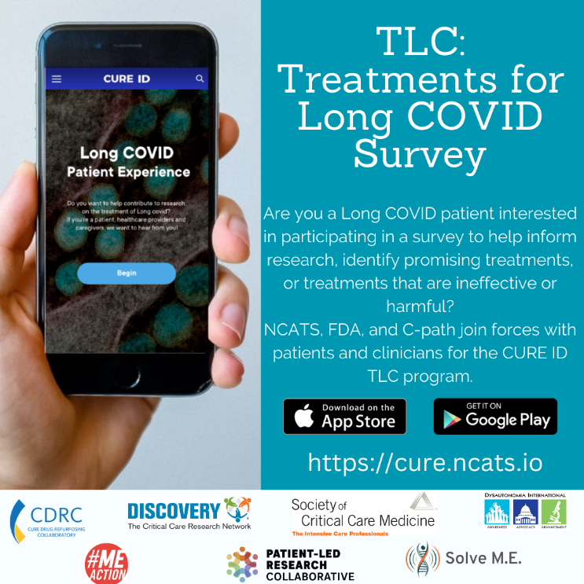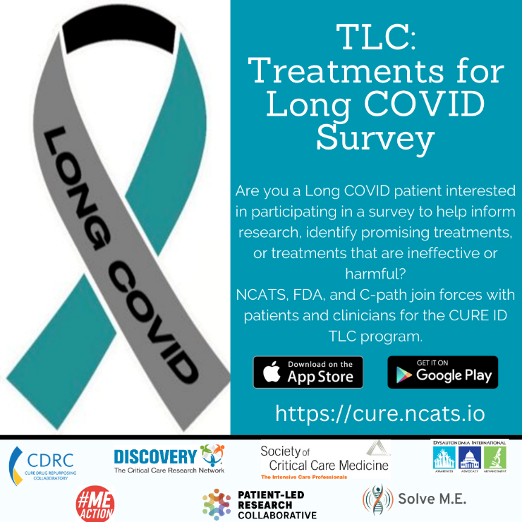
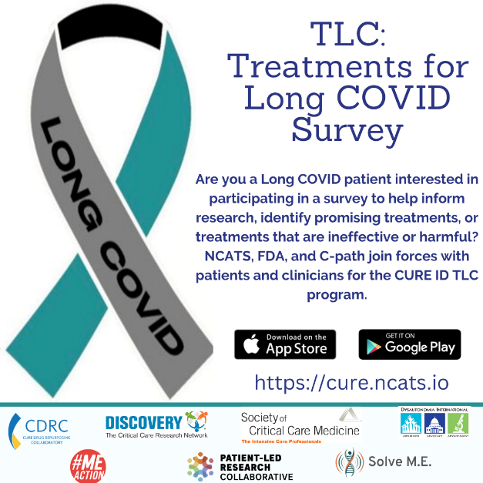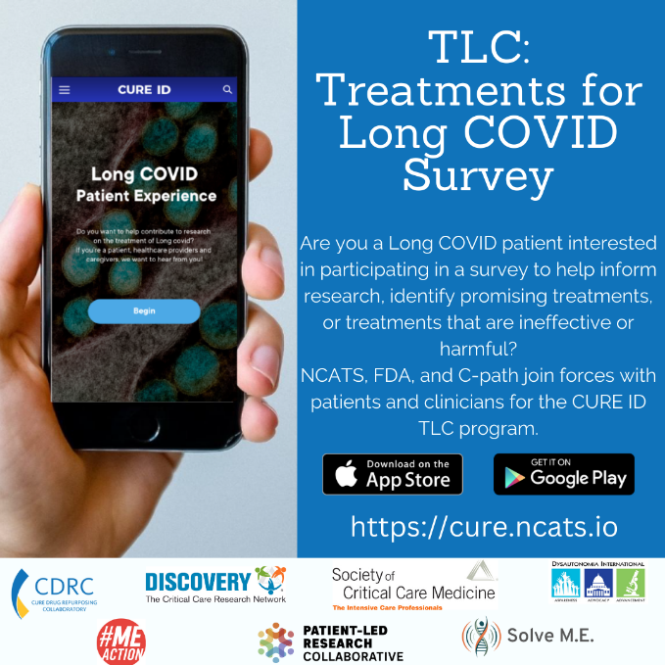

Sample Facebook or Instagram Text:
- Attention all people with Long COVID!
  - If you're navigating life after an acute COVID-19 infection and continuing to experience symptoms, your treatment experiences hold immense value! Participate in our research survey, as we aim to gain deeper insights into Long COVID symptoms and treatments, shaping the path for future clinical trials. Join us today by participating in our online research survey. Visit CURE-ID (ncats.io) or download the “CURE ID” mobile app now!

- Calling all those who continue to feel the impact of COVID-19 – your perspective is invaluable! Take part in our research survey to illuminate the intricacies of Long COVID, sharing insights about its hurdles, treatments that worked, treatments that didn’t work, and personal journeys. Together, let's learn about potential treatment options and try to shape future clinical trials. Visit CURE-ID (ncats.io) or download the “CURE ID” mobile app now!

- Is Long COVID affecting you or someone close to you? Your involvement in our online research survey can play a pivotal role in advancing our understanding of the symptoms and treatments of Long COVID. Your valuable input has the potential to drive improvements in treatments for those navigating the challenges of Long COVID and help to inform future clinical trials. Visit CURE-ID (ncats.io) or download the “CURE ID” mobile app now!

- Join the patient and clinician partners, along with the NIH, FDA, and C-Path’s CURE ID platform to advance our understanding of the symptoms and treatments of Long COVID. What treatments are you taking and how have they impacted you? Take the CURE ID Treatments for Long COVID (TLC) Survey now by visiting CURE-ID (ncats.io) or download the “CURE ID” mobile app now!

Instagram Hashtags:
#LongCOVIDSurvey #COVID19Research #TLCSurvey #HealthResearch #CommunityResearch #PatientImpact #LongHaulers #LongCOVIDAwareness, #TreatLongCOVID #LongCOVID #COVID19 #covidlong #LC #PASC #treatment

Link to CURE ID: CURE-ID (ncats.io)
CURE ID Long COVID FAQ Document: https://cure.ncats.io/assets/faq-long-covid.pdf
Accessibility note: If users need assistance entering cases, please reach out to curesupport@nih.gov, we have staff who are available to assist by email, phone, and/or Zoom.

Email Announcement Text

Dear [add person’s name you are emailing]!
CURE ID has developed a treatment survey for Long COVID patients which I’m encouraging people to contribute their experiences to.
The goal is to understand the symptoms Long COVID patients are experiencing, the medications they have tried, and whether they feel any of the medications have had an impact on their symptoms (positive or negative).
This data is meant to generate hypotheses and to help inform which drugs are studied in large, well-controlled, randomized clinical trials. Patients, care partners, and healthcare providers can all submit their experiences as case reports.
This is meant to be a community resource, so once a Long COVID case is entered in CURE ID, it becomes publicly viewable (the data is de-identified and the contributor’s name is not shown with the case if it’s a patient/care partner). All users can see the individual case reports, as well as the aggregate treatment experiences.
Please go to the CURE ID website (https://cure.ncats.io) or download the “CURE ID” mobile app from the App or Play Store and complete the Long COVID case report form. It takes most people ~20-45 minutes to complete, but you can save it along the way, so you don’t have to enter it in one sitting. You can also limit your entry to only the required data on the drug, symptom, and treatment outcome.
You must register to enter a case (so that you can be contacted if there are any questions by the CURE ID staff) and then can click the banner on the homepage to go directly to the Long COVID case report form. You can also access it through the Create menu by selecting the Patient/Care Partner or Healthcare Provider form and entering the disease as Long COVID. All patient and care partner case reports are anonymous and healthcare providers can choose whether they want their name displayed with their case. If you have any questions, run into any problems, or want to provide any feedback, you can email curesupport@nih.gov. You can also read the programs FAQ document here: https://cure.ncats.io/assets/faq-long-covid.pdf
If you have accessibility issues or require support in entering your case, CURE ID has staff who are available to assist in case entry. Please email the curesupport@nih.gov address and the CURE ID staff can set up a zoom call or phone call, or answer questions via email, depending on your needs.
This platform has been developed with the input of patient, clinician, and research partners who have contributed to the development of this program including: the Patient-Led Research Collaborative (PLRC), Dysautonomia International (DI), Solve ME/CFS, and ME Action, among many others. It builds off the NCATS/NIH, FDA, and C-Path-run CURE ID platform. This research study has been reviewed by the NIH and FDA IRB’s and was determined to be exempt.
Thanks for your help!
[add your name here]

Talking Points – CURE ID for Long COVID

- CURE ID is a website and mobile app which allows the global community to hear from clinicians and patients about how Long COVID and other challenging diseases are being treated in the real-world environment.

- A special Long COVID reporting platform for patients and clinicians has now been included in the CURE ID website and app.

- The CURE ID Long COVID platform was developed as a collaboration between FDA, NCATS/NIH, and C-Path’s CURE Drug Repurposing Collaboratory (CDRC) along with Long COVID clinicians, researchers, patients, and advocates.

- It allows reporting of symptoms of Long COVID, their severity, the medications that have been tried, and whether the individuals feel any of the medications have had an impact on their symptoms (positive or negative).

- This will serve as an important surveillance tool for the clinical/patient community to understand the symptoms of Long COVID that patients are experiencing, those which they feel are most debilitating, and the drugs that are being used to treat them. This may provide clues about drugs or combinations of drugs that are potentially beneficial and may be studied formally in randomized controlled trials or suggest drugs that are not helpful, and which should not continue to be tried as treatments for Long COVID.

- Once Long COVID patients, care partners, or healthcare providers submit their case report to CURE ID, they are reviewed by CURE ID staff, and if approved, become publicly viewable (though the cases are de-identified).

Direct Links to Long COVID Case Report Forms

Long COVID Clinician Case Report Form:
https://cure.ncats.io/create/quick-case?form-type=pasc&report-type=clinician

Long COVID Patient Case Report Form:
https://cure.ncats.io/create/quick-case?form-type=pasc&report-type=patient

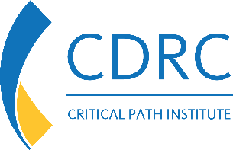
Partners Involved and Who they are:
- Critical Path Institute (C-Path), CURE Drug Repurposing Collaboratory (CDRC)
  - Role: Public-Private Partnership supporting CURE ID
  - Communication liaison: Claire Bassetti • cbassetti@c-path.org

- National Center for Advancing Translational Sciences (NCATS/NIH)
  - Role: Hosts the CURE ID Platform
  - Communication liaison: Meghan Mendick
• meghan.mendick@nih.gov

- U.S. Food and Drug Administration (FDA)
  - Role: Created CURE ID in collaboration with NCATS/NIH
  - Communication liaison: Heather Stone • Heather.Stone@fda.hhs.gov

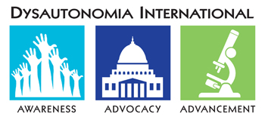
- Dysautonomia International (DI)
  - Role: Advocacy organization. Helping bring engagement to CURE ID through community network.

- Patient-Led Research Collaborative (PLRC)
  - Role: Advocacy organization. Helping bring engagement to CURE ID through community network.

- #MEACTION
  - Role: Advocacy organization. Helping bring engagement to CURE ID
through community network.

- SOLVE M.E.
  - Role: Advocacy organization. Helping bring engagement to CURE ID through community network.

- Discovery, The Critical Care Research Network of the Society for Critical Care Medicine (SCCM)
  - Role: Supports CURE ID’s COVID-19 data efforts, including Long COVID

